The ocean, A summer adventure!  When:  June1-August 21st  - Week 1 & 2 Oceanic Transportation  - Week 3 & 4…. Let’s go Tide pooling  - Week 5&6… “Move it move it” to Madagascar  - Week 7&8…. Travel to the Galapagos Islands  - Week 9& 10… “G’Day” to Australia’s Coral Reefs  - Week 11& 12…. Two weeks at the Beach  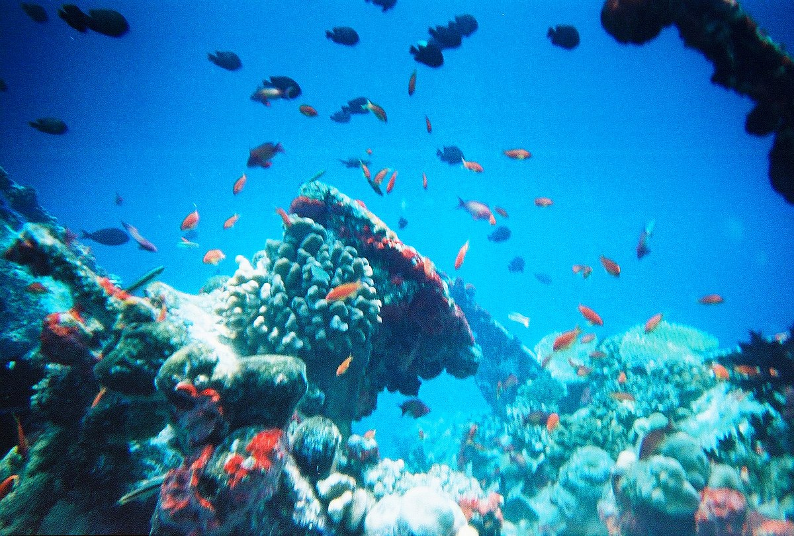  This Photo by Unknown Author is licensed under CC BY-SA | 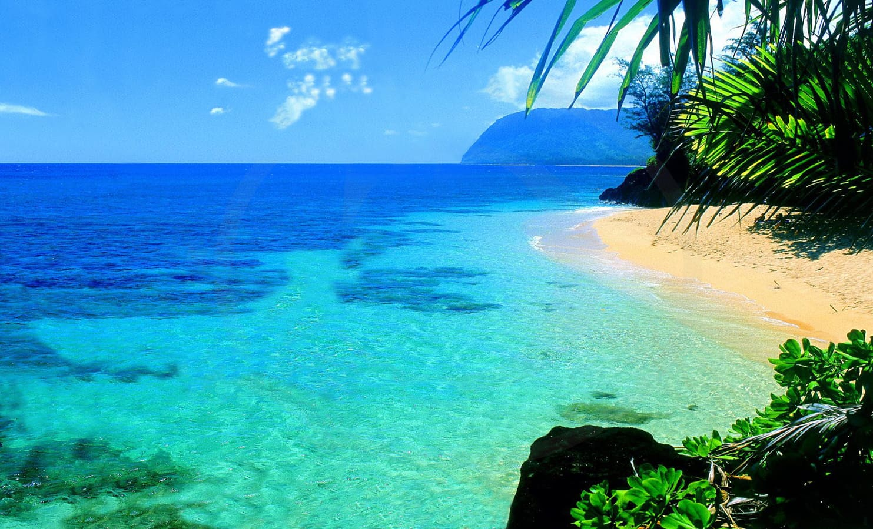  Our exploration will begin with how to get across, under and through the Ocean. Lots of opportunity to build and create travel vehicles too! Our travels to Australia, the Galapagos and Madagascar will focus on the animals and the Flora and fauna of each. Lastly we end our travels with a week long vacation at the “beach”.  Camp will be charged on a 4-week basis, starting June 1st.  How to Reserve your child’s space:  Fill out the attached registration form and return with your $50 non-refundable registration fee by May 20^{h}, 2020.

