Dear VMS Families,
We are two full months into our new year, with all sorts of interesting things happening in our world. At the school level, classrooms are full and normalized, and hopefully we are headed into a healthier season. With that being said, I know many families are concerned with the Novel Coronavirus. As of now the risk seems to be low in children (to date no one under age 13 has been infected). To help protect our community, please take the necessary precautions if you have been traveling in any country where there has been an outbreak or just traveling in larger airports. This may include up to 14 days of quarantine. With everyone’s cooperation, we will be able protect the children, families and staff at VMS.
Thank you for your attendance at our Parent/Child classroom visit last month. I love wandering from room to room and observing the children sharing work with their families. They show such growth and love of their environments-and its joyful to watch.
The primary and toddler classrooms are offering conferences on Monday March 16th, from 7-6pm. The conference sign-up sheets are available by your child’s classroom. Childcare is available during your conference.
Our primary registration for Fall 2020 has been completed, with great success! We are so thankful that you have chosen us as your village and partners in the education of your children.
This summer we are excited to be headed out on an Ocean Adventure! During the 8-weeks of camp, June 22nd-August 14th, the children will learn about the care and feeding of our Oceans, study and build oceanic transportation vehicles, visit the Coral Reefs in Australia, the Galapagos Island and Madagascar. We will end with a week at the beach for some sun and sand. For those of you who are new to our school, our summer program is weekly. You can come as little or as much as your schedule needs. More info coming soon!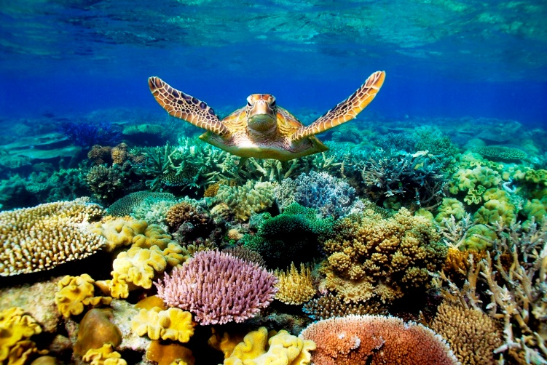

Calendar
Sunday March 8th……………………. Daylight savings time begins (spring forward one hour)
Friday March 13th………………………. School Closed-Inservice
Monday March 16th…………………School closed for Primary and Toddler conferences (childcare available during conferences)
Monday March 30-Friday April 3rd……School Closed Spring Break

In Gratitude,
Lisa and Trisha

